* Copy of the launch file from ROS Ag and work to get each element to load without error
* Go back and piece together your startup commands and get each of them working 1-by-1
* One of the differences is the TTGO board is controlling steering and speed. When the switch is set to be in “ROS Mode”, then it will need to listen to cmd_vel

| Old fashioned way of starting things:  $ bash ros_start.sh (gui) - step 1   | roslaunch teensy_launch.launch  roslaunch nmea_serial_driver.launch | | --- |   $ python serial_to_ros.py (gui) - step 1 # takes output from IMU nano and publishes it  $ roslaunch tractor_teleop drive.launch (gui) - step 2  $ roslaunch nmea_serial_driver.launch (gui) - step 3  $ roslaunch nmea_serial_driver.launch  /home/ubuntu/catkin_ws/src/nmea_navsat_driver/launch  $ rosrun beginner_tutorials gps_odom.py (gui) - step 4  $ roslaunch lawn_tractor_sim lawn_tractor.launch (gui) - step 5 |
| --- | --- |

| Previous way of starting things:   | roslaunch teensy_launch.launch  *# used to set parameters and start rosserial_python to get data from Teensy boards to ROS*  *publish*  *# steering angle, speed and control the steering motor and transmission control motor*   | <rosparam param="steering">[-14000.0, 13500.0, 0.0, 60.0, 3.0]</rosparam>  <rosparam param="speed">[1000.0, 1290.0, 1600.0, 135.0, -100.0, 70.0, 5.0, 0.0, 20.0]</rosparam>  <node ns="transmission_teensy" name="transmission_cntrl" pkg="rosserial_python" type="serial_node.py" args="/dev/transmission_control" output="screen" />  <node ns="left_speed_teensy" name="left_speed" pkg="rosserial_python" type="serial_node.py" args="/dev/odom_left" output="screen" />  <node ns="front_angle_teensy" name="front_angle" pkg="rosserial_python" type="serial_node.py" args="/dev/front_angle" output="screen" />  <node ns="steer_motor_teensy" name="steer_motor" pkg="rosserial_python" type="serial_node.py" args="/dev/steer_motor" output="screen" /> | | --- |   roslaunch nmea_serial_driver.launch  *# used to start* nmea_navsat_driver   | <arg name="port" default="/dev/ttyUSB0" />  <arg name="baud" default="4800" />  <arg name="frame_id" default="gps" />  <arg name="use_GNSS_time" default="False" />  <arg name="time_ref_source" default="gps" />  <arg name="useRMC" default="False" />  <node name="nmea_serial_driver_node" pkg="nmea_navsat_driver" type="nmea_serial_driver" output="screen">  <param name="port" value="$(arg port)"/>  <param name="baud" value="$(arg baud)" />  <param name="frame_id" value="$(arg frame_id)" />  <param name="use_GNSS_time" value="$(arg use_GNSS_time)" />  <param name="time_ref_source" value="$(arg time_ref_source)" />  <param name="useRMC" value="$(arg useRMC)" />  </node> | | --- | | | --- | --- | --- |   $ python serial_to_ros.py # takes output from IMU nano and produces ros topics from a serial data stream  $ roslaunch tractor_teleop drive.launch   | <launch>  <!-- Joystick Input Node -->  <include file="$(find tractor_teleop)/launch/drive_teleop.launch"/>  <!-- Multiplex Motor Commands Node -->  <include file="$(find tractor_teleop)/launch/cmd_vel_mux.launch"/> {this let the joystick take over if needed}  </launch> | | --- |   $ rosrun beginner_tutorials gps_odom.py  *# Subscribes to* heading and fix and then publishes odom, plus broadcasts a transform between odom and base_footprint   | self.heading_sub = rospy.Subscriber("heading", QuaternionStamped, self.heading_callback)  self.fix_sub = rospy.Subscriber("fix", NavSatFix, self.gps_callback)  self.odom_pub = rospy.Publisher("odom", Odometry, queue_size=1)  odom_broadcaster.sendTransform((_xg, _yg, 0.0), self.odom_quat, rospy.Time.now(), "base_footprint", "odom") | | --- |   $ roslaunch lawn_tractor_sim lawn_tractor.launch  *# Set the URDF, pkg="robot_state_publisher", node pkg="mbf_costmap_nav", node pkg="lawn_tractor_navigation", pkg="map_server" and fake localizations:*  *<node pkg="tf" type="static_transform_publisher" name="map_to_odom" args="0.0 0.0 0.0 0 0 0.0 map odom 100"/>*  *<node pkg="tf" type="static_transform_publisher" name="map_to_utm" args="0.0 0.0 0.0 0 0 0.0 map utm 100"/>* |
| --- | --- | --- | --- | --- | --- |

I think you want a tree similar to below

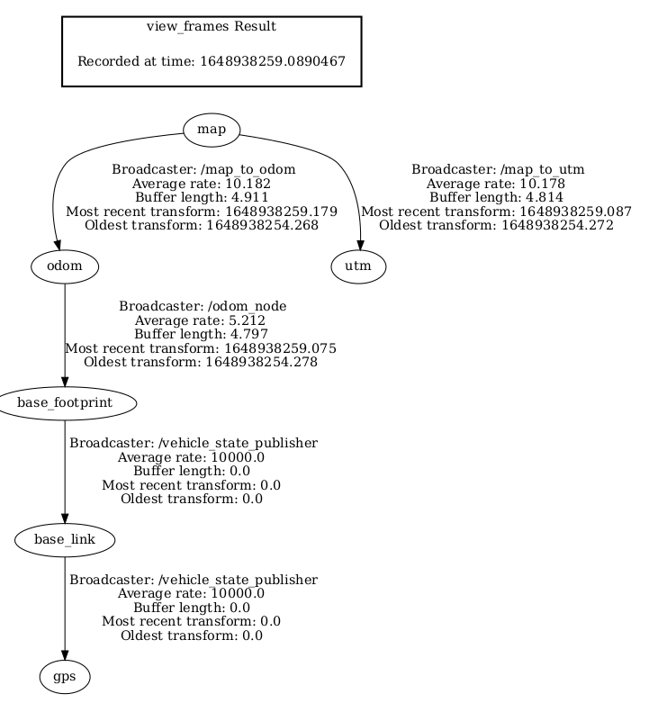

So I’m going to:

* $ roslaunch /home/tractor/catkin_ws/src/nmea_navsat_driver/launch/nmea_serial_driver.launch
* $ cd /home/tractor/catkin_ws/src/beginner_tutorials/scripts
* $ chmod +x gps_odom.py
* $ rosrun beginner_tutorials gps_odom.py
* $ rosrun /home/tractor/catkin_ws/src/beginner_tutorials/scripts/gps_odom.py
* $ roslaunch lawn_tractor_sim lawn_tractor.launch (execute this a piece at a time and work through the issues)
* $ source /home/tractor//catkin/devel/setup.bash

$ python3

>>> help("modules")

$ geonav_transform not listed

This url helped with the gps_odom.py tuple issue

<http://www.tcrobots.org/Lawntractor/slack2html/html/lawntractor2020.html>